**PG FINDER**

# Project Report

Submitted as Partial Fulfillment of

Master of Computer Application

Semester-VI

**Developed at**

**Radixweb Pvt Ltd.**

**Developed by**

**MohammadAlmas Shaikh (202200719010131)**

**Under Guidance of**

Dr. Prerna Agrawal, FCAIT

Mrs. Varsha Obrori, Radixweb Pvt Ltd

Faculty of Computer Applications & Information Technology (FCAIT)

GLS University

Ahmedabad-380006

| **Project Title:** | **PG Finder** |
| --- | --- |
| **Description:** | **“PG Finder” is an online paying guest system in which users can find several paying accommodations and book nearby the workplace or desired place.** |
| **Aim:** | **The Main objective of system is provide PG accommodations to user as per their need** |
| **Category**: | **Web Application** |
| **Tools Used / Required:** | **Development side**  **FrontEnd:React.js**  **BackEnd:Python**  **Framework:django**  **Database:-Firebase Cloud Fire store** |
| **Developed at:** | **Radixweb PVT LTD** |
| **Developed By:** | | **Enro No** | **Name** | **Institute** | **Contribution** | | --- | --- | --- | --- | | **202200719010131** | **MohammadAkmas Shaikh** | **GLS University** | **BackEnd** | |
| **Guided By:** | | **Internal at Institute** | **External at company** | | --- | --- | | **Name:** Dr. Prerna Agrawal, FCT  **Designation: Assistant professor** | **Name: Varsha Obrori**  **Designation: Technical Team Lead** | |

**Certificates**

**Acknowledgment**

* **extend our heartfelt gratitude to all those who contributed to the successful completion of the PG Finder project. Firstly, we would like to express our deepest appreciation to our internal guide, Dr Prerna Agrawal , for their invaluable mentorship, guidance, and unwavering support throughout every stage of the project. Their expertise and insights were instrumental in steering us in the right direction and ensuring the project's success.**
* **I would like to express our gratitude to all those who contributed to the development and completion of the PG Finder project. Firstly, we extend our thanks to our project team members for their dedication and hard work throughout the process.**
* **Special thanks are due to Varsha Obrori and Radixweb PVT LTD for their invaluable assistance in providing resources, guidance, and support during the execution of this project**
* **We are also thankful to the participants and users who provided feedback and suggestions, helping us improve the functionality and usability of the PG Finder platform.**
* **Without the collective efforts and support of everyone involved, this project would not have been possible.**

**Company Details**

* **Radixweb Pvt Ltd is an Ahmedabad-based software development company. Founded in 2000, Radixweb specializes in providing IT services and solutions to clients globally. The company offers a wide range of services including custom software development, web development, mobile application development, enterprise solutions, software testing, and IT consulting.**
* **Radixweb has expertise in various technologies such as Microsoft .NET, Java, PHP, Python, JavaScript frameworks, mobile app development platforms like iOS and Android, and more. They serve clients across various industries including healthcare, finance, manufacturing, retail, and logistics.**
* **The company has established itself as a reliable technology partner for businesses looking to innovate and leverage digital solutions for their growth and efficiency. Radixweb focuses on delivering quality services, adhering to deadlines, and providing excellent customer support, which has contributed to its reputation in the IT industry.**

**Index Page**

**Introducation**

**Project Defination**

* **PG Finder is a web Application designed to streamline the process of finding suitable paying guest accommodations.. Whether you're looking for a PG with specific amenities, in a particular location, or within a certain budget, PG Finder is here to simplify your search**

**Existing System**

* **In understanding the landscape of finding paying guest (PG) accommodations, it's crucial to examine the prevailing methods and challenges within the existing system. The current approach predominantly revolves around conventional techniques such as word-of-mouth recommendations, classified advertisements, and manual online searches**

**Need Of New System**

* **Intuitive Interface: The introduction of a smoother user experience ensures that navigating through the PG Finder platform is effortless and enjoyable for users of all backgrounds and technical proficiencies.**
* **Efficient Functionality: By optimising performance and responsiveness, we aim to minimise loading times and streamline processes, allowing users to accomplish their tasks with greater efficiency.**
* **Room Tour: Implementing 360-degree Room View Tour Which make Application more attractive.**
* **Continuous Improvement: Feedback gathered from 360-degree reviews serves as valuable insights for identifying areas of improvement and refining our platform to better serve the needs of our users over time**

**Objective Of New System**

* **The primary goal is to offer comprehensive information about available PG accommodations, encompassing details such as location, amenities, meal provisions, pricing, accessibility via maps, transportation options, and safety protocols**
* **customers will have the ability to reserve their desired accommodation and facilitate monthly rent payments seamlessly.**

**Hardware Requirement**

* **Processor: Multi-core processors (e.g., Intel Xeon, AMD Ryzen)**
* **RAM: 8GB TO 16GB**
* **Storage : 256 GB SSD OR 1 TB HSD**

**Software Requirement**

* **VS CODE : VS Code can serve as the primary integrated development environment (IDE) for developers working on the PG Finder project. It provides a feature-rich environment for writing, editing, and debugging code efficiently.**
* **Chrome :Many users prefer Chrome Browser due to its user-friendly interface, speed, and features such as tab management, bookmarks synchronization, and customizable settings, making it a preferred choice for accessing PG Finder.**

**Feasibility Study of the PG Finder**

**Market Analysis:**

* **Evaluate demand for PG accommodations in target markets.**
* **Analyze trends, preferences, and pain points of individuals seeking PG accommodations.**
* **Assess competitive landscape, including existing PG accommodation platforms.**

**Technical Feasibility:**

* **Assess technical requirements and constraints for PG Finder development.**
* **Evaluate availability of necessary technologies, tools, and expertise.**

**Operational Feasibility:**

* **Evaluate operational processes and workflows for running PG Finder.**
* **Identify operational challenges and risks, and develop mitigation strategies.**

**User Acceptance and Usability:**

* **Gather user feedback through surveys or focus groups.**
* **Assess user acceptance and satisfaction with existing PG accommodation search methods.**
* **Identify usability issues and preferences to inform PG Finder design and development.**

**Conclusion and Recommendations:**

* **Summarize findings of feasibility study and assess viability of PG Finder system.**
* **Make recommendations on project continuation, scope modification, or alternative solutions.**

**System Architectural diagram :- UML Diagram**

* **CustomerUseCaseDiagram** 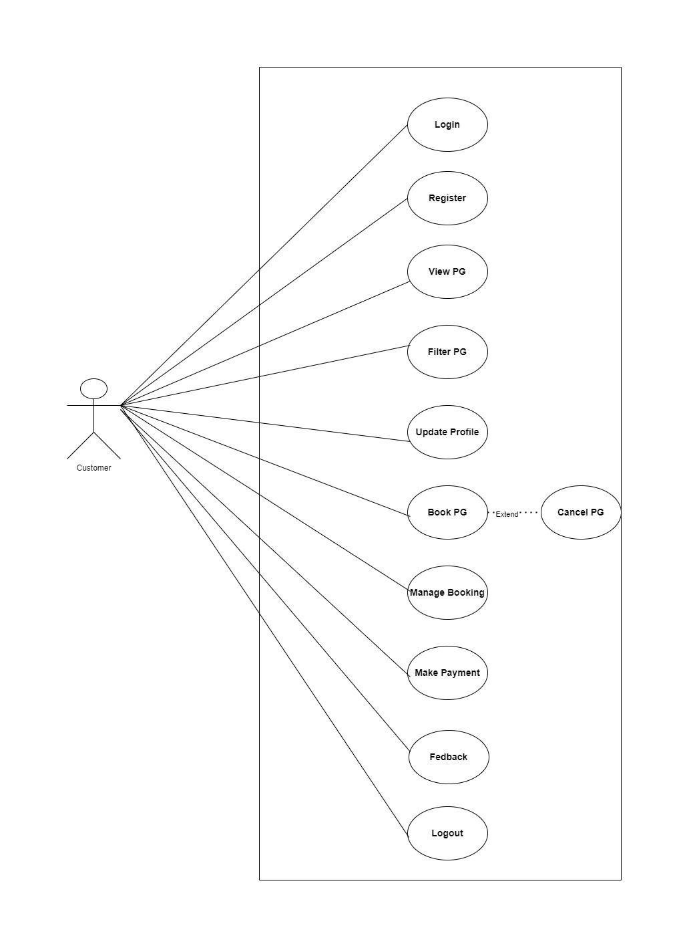

**AdminUseCaseDiagram**

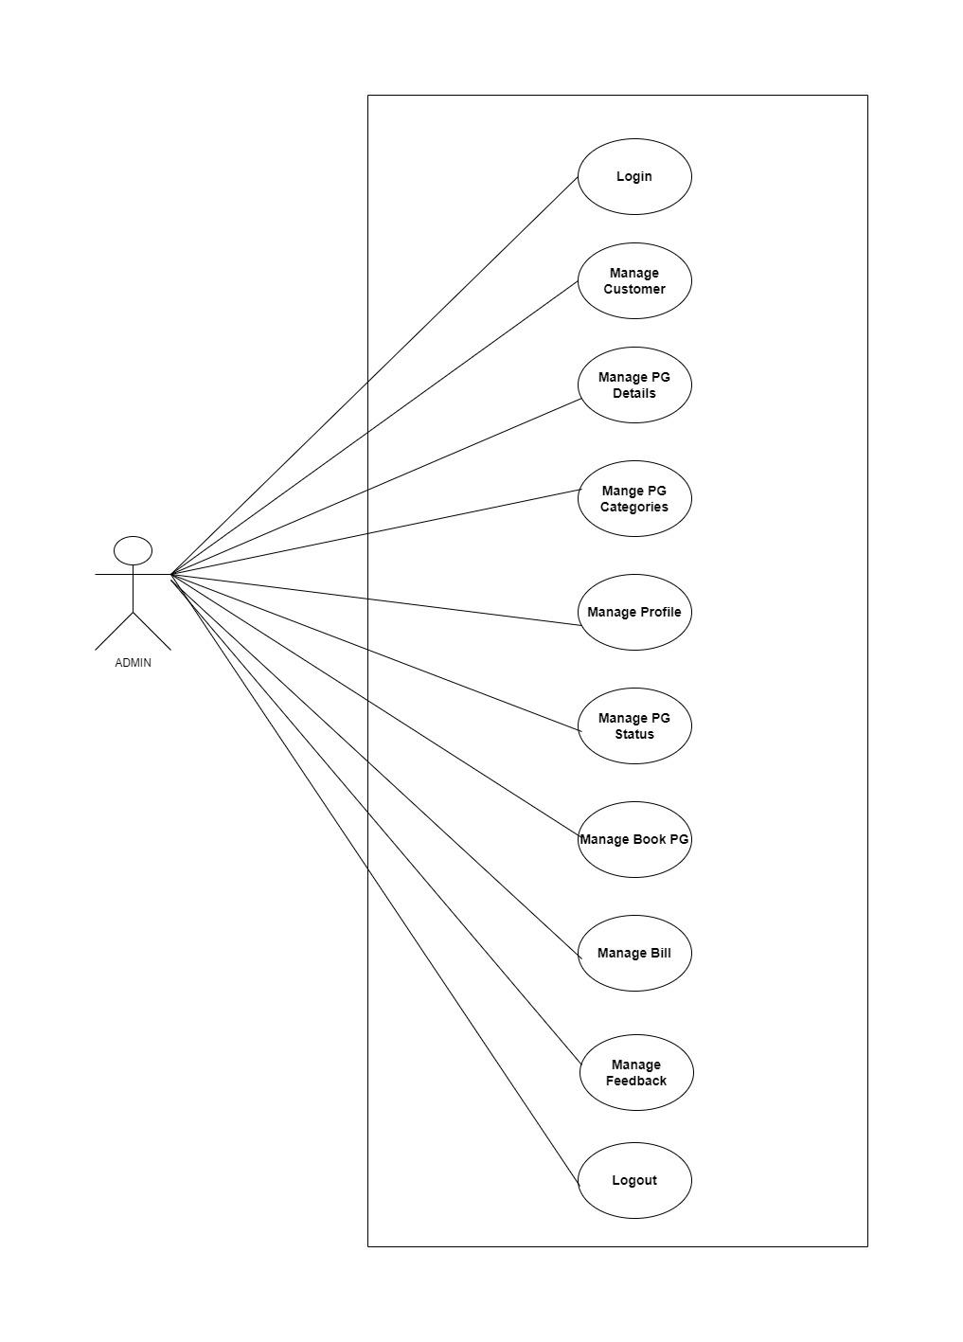

**AdminActivityDiagram**

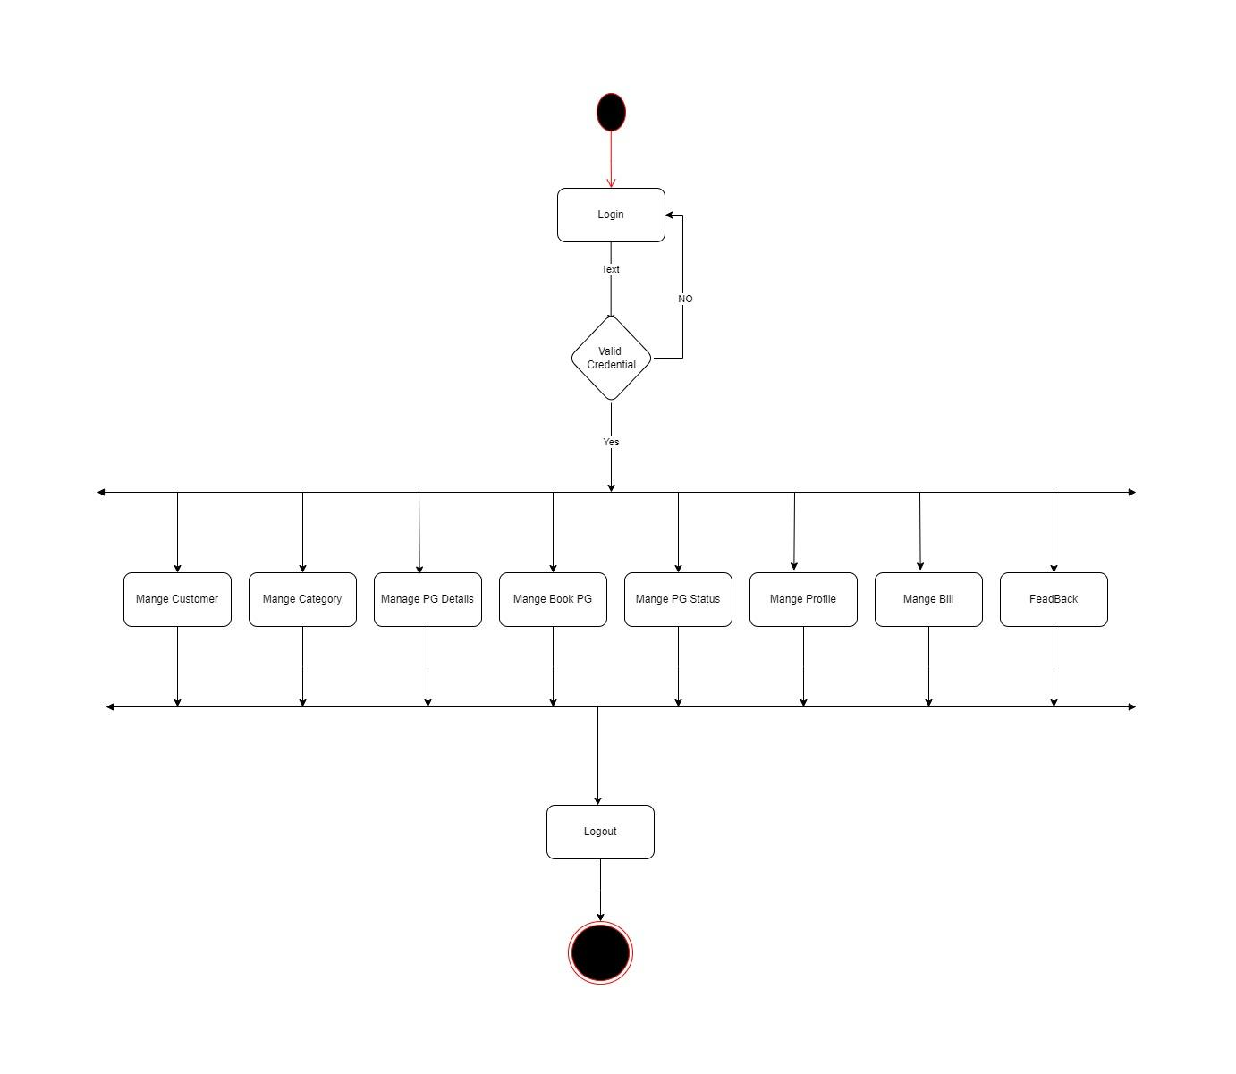

**UserActivityDiagram**

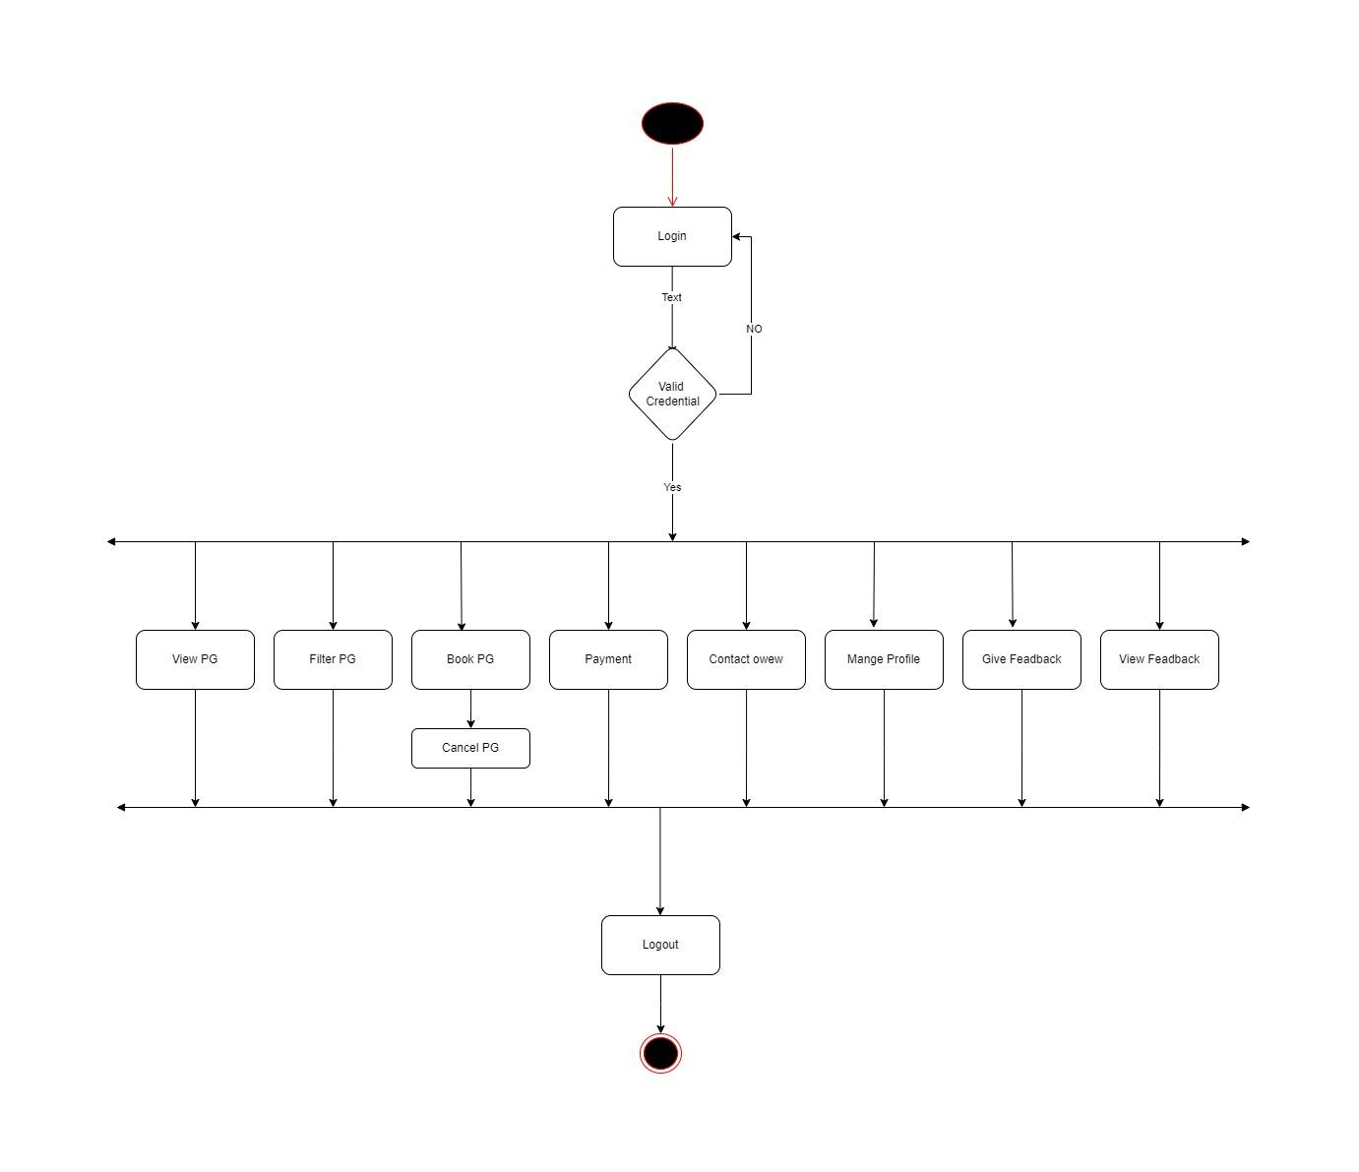

**CustomerSequenceLogin-Register**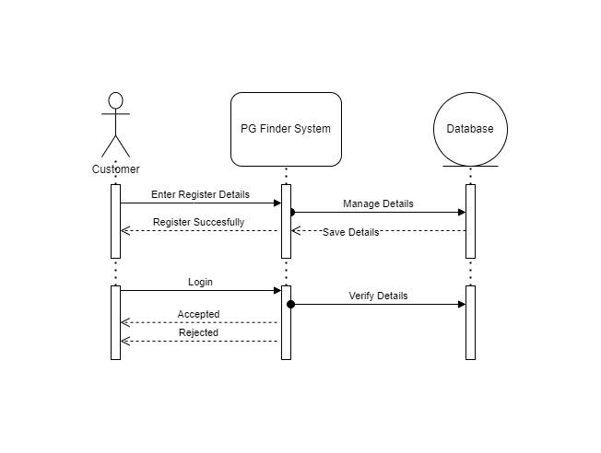

**BookingCustomerSequence**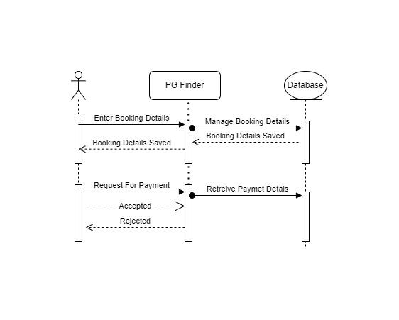

**BookingAdminSequnece**

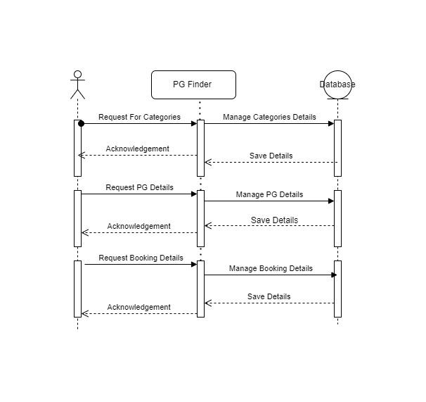

**ClassDiagram**

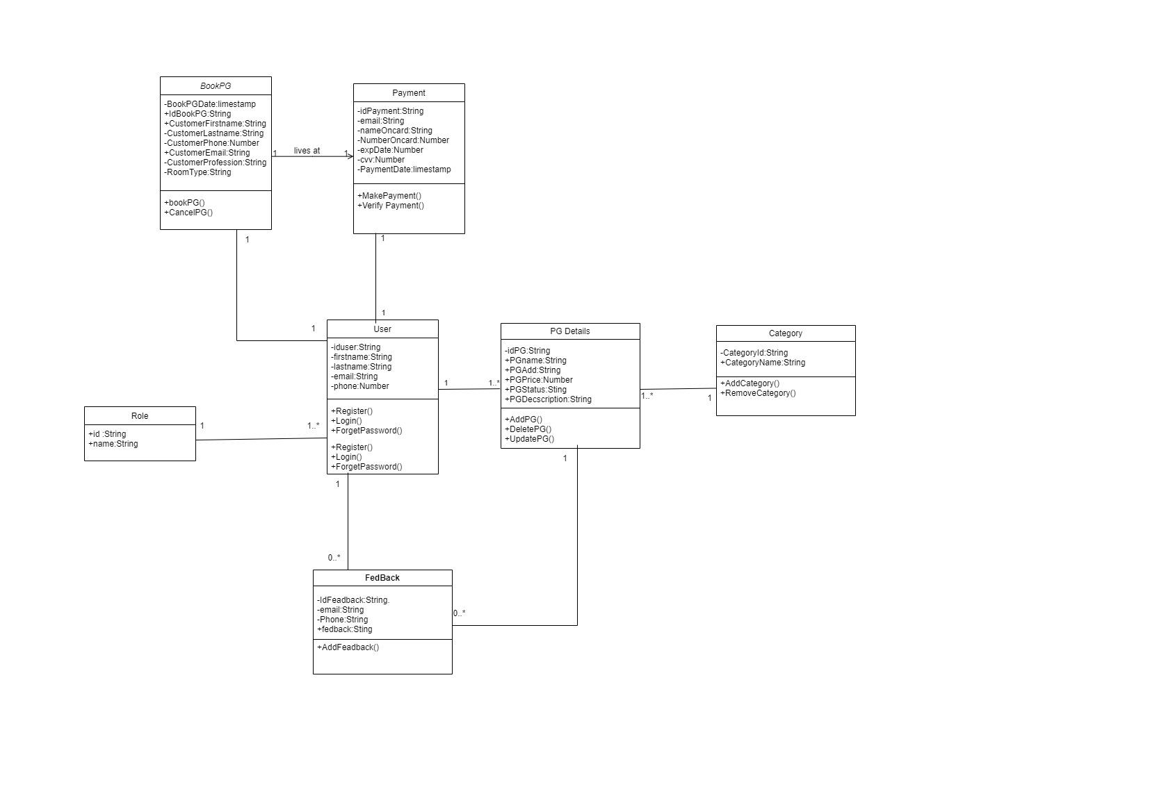

**Data Dictionary**

**Table Name: PG_details**

**Description: This table stores all details of Paying Guest (PG) facilities.**

| Column Name | Data Type | Key Constraint | Description |
| --- | --- | --- | --- |
| id_pg | String (PK) | Primary Key | Unique identifier for each PG facility. |
| pg_name | String (30) | Not Null | Name of the PG facility. |
| pg_owner | String (30) | Not Null | Name of the PG owner. |
| publish_date | TimeStamp | Not Null | Date and time the PG information was published. |
| pg_area | String (20) | Not Null | Area where the PG facility is located. |
| pg_city | String (20) | Not Null | City where the PG facility is located. |
| pg_state | String (20) | Not Null | State where the PG facility is located. |
| pg_price | String (6) | Not Null | Monthly rent of the PG facility (including currency symbol). |
| pg_status | String (10) | Not Null | Availability status of the PG facility (e.g., "available", "unavailable"). |
| pg_amenities | Array(15) | Not Null | List of amenities offered by the PG facility (up to 15). |
| pg_house_rules | Array(15) | Not Null | List of house rules of the PG facility (up to 15). |
| pg_rooms | Array(3) | Not Null | Details of room types available in the PG (up to 3). |
| pg_food | Array(3) | Not Null | Food options available in the PG (up to 3). |
| pg_desc | String (100) | Not Null | Description of the PG facility. |
| pg_image | Map | Not Null | Stores the PG image information as a key-value pair (e.g., path, filename). |
| category | String (5) | Not Null | Category of the PG facility (e.g., "men's", "women's", "unisex"). |

**Table Name: Registration**

**Description: This table stores all details of user registration**

| Column Name | Data Type | Key Constraint | Description |
| --- | --- | --- | --- |
| id_regi | String (PK) | Primary Key | Unique identifier for each registered user. |
| profile_image | Map | - | Stores the profile image information as a key-value pair (e.g., path, filename). |
| first_name | String (25) | Not Null | First name of the registered user. |
| last_name | String (25) | Not Null | Last name of the registered user. |
| email | String (25) | Not Null | Email address of the registered user. |
| phone_number | Number (10) | Not Null | Phone number of the registered user. (10 digits) |
| address | String (50) | - | Address of the registered user. |
| role | String (10) | Not Null | Role assigned to the registered user. (e.g., "admin", "user") |

**Table Name: BookPG**

**Description: This table stores details of PG bookings.**

| Column Name | Data Type | Key Constraint | Description |
| --- | --- | --- | --- |
| id_bookpg | String (PK) | Primary Key | Unique identifier for each PG booking. |
| bookpg_date | TimeStamp | Not Null | Date and time the PG was booked. |
| profession | String | Not Null | Profession of the customer who booked the PG. |
| room_type | String | Not Null | Type of room booked in the PG. |
| id_pg | String (FK) | Not Null | Foreign Key referencing id_pg in PG_details table. |
| id_regi | String (FK) | Not Null | Foreign Key referencing id_regi in Registration table. |

**Table Name: Payment**

**Description: This table stores details of payments made for PG bookings.**

| Column Name | Data Type | Key Constraint | Description |
| --- | --- | --- | --- |
| id_payment | String (PK) | Primary Key | Unique identifier for each payment transaction. |
| payment_date | TimeStamp | Not Null | Date and time the payment was made. |
| payment_method | String | Not Null | Method used for the payment (e.g., "credit card", "debit card"). |
| name_on_card | String (30) | Not Null | Name of the cardholder as it appears on the payment card. |
| number_on_card | Number (16) | Not Null | 16-digit number of the payment card. |
| exp_date | Date | Not Null | Expiry date of the payment card (YYYY-MM-DD format). |
| id_pg | String | - | Stores the PG facility ID associated with the payment. |
| id_regi | String (FK) | Not Null | Foreign Key referencing id_regi in Registration table. |

**Table Name: Feedback**

**Description: This table stores details of user feedback for PG facilities.**

| Column Name | Data Type | Key Constraint | Description |
| --- | --- | --- | --- |
| id_feedback | String (PK) | Primary Key | Unique identifier for each feedback entry. |
| review | String (50) | Not Null | User's review of the PG facility (up to 50 characters). |
| feedback_date | TimeStamp | Not Null | Date and time the feedback was submitted. |
| rating | Number | Not Null | User's rating of the PG facility (numerical score). |
| id_pg | String (FK) | Not Null | Foreign Key referencing id_pg in PG_details table. |
| id_regi | String (FK) | Not Null | Foreign Key referencing id_regi in Registration table. |

**System Screenshot**